**Focus Keyword: Special Education Teacher Jobs**

**Meta Title: Special Education Teacher Jobs | Educatecast**

**Meta Description: The training of pupils with physical, emotional, mental, and learning challenges comes under special instructors.**

**Feature Image:**

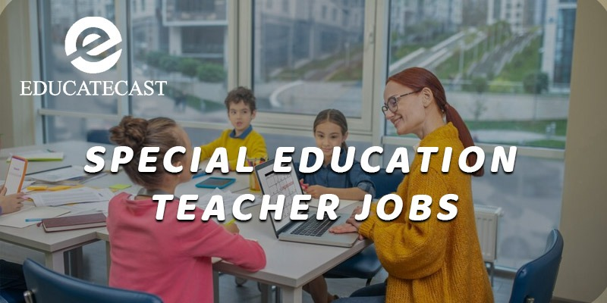

**Special Education Teacher Jobs**

The education and training of pupils with **physical, emotional, mental, and learning** challenges is under the direction of special education instructors working under **Special Education Teacher Jobs** . They create and present courses that are tailored to the unique requirements and capacities of the kids they are in charge of.

Preschool, elementary, middle, and high school students are taught by special education instructors. In 2016, there were around 439,300 special education instructors working in the United States.

**Main Goal of Special Education Teacher Jobs**

The main goal is to give special education pupils learning opportunities and experiences that will enable them to reach their full potential in terms of **intellectual, emotional, physical, and social development.** **Create or alter curriculum**, and **tailor lessons** and other **teaching resources** to different student skill levels. Work independently, in a team, within a department, or as an itinerant worker as directed.

**Special Education Teacher Jobs description**

From 2016 to 2026, the demand for special education instructors is anticipated to increase at a pace of roughly 8%, which is faster than the national average for all occupations. This is because numerous physical, emotional, mental, and learning problems are now more effectively and promptly identified and screened for.

There is a constant demand for these instructors since federal and state laws mandate that school systems provide free education to kids with disabilities.

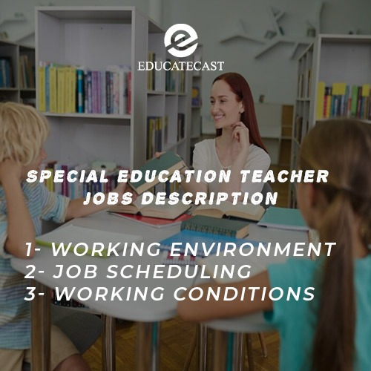

**Working Environment**

Many special education instructors work in elementary, middle, and high schools that are public or private, but they may also instruct at **child care facilities**. Others work in community-based organizations that support school-based education or residential and day programs that cater to the requirements of special or impaired students.

This line of work may be inspiring and satisfying in any setting, but it can also be emotionally taxing and difficult. Dealing with kids who have physical challenges may be difficult physically as well.

**Job Scheduling**

The majority of special education instructors work during school hours and on school days, although they may also stay late to mark papers and handle administrative duties. Although some schools provide summer school programs that may necessitate additional months of work, special education instructors normally take the summers off. Usually, teachers are off for both the midwinter and spring holidays.

**Working Conditions:**

**Environmental Factors, Physical Demands, and Mental Demands**; Keep emotional control when under pressure. Frequent standing, stooping, bending, kneeling, pushing, and tugging. Move any desks, media equipment, or other classroom or adapted equipment that is in tiny stacks.

Pupils with physical impairments may need to be lifted and positioned, conduct may need to be controlled physically, and assistance with nonambulatory students may be needed.

**Skills & Competencies for Special Education Teacher Jobs**

Teachers in special education need a variety of abilities, such as **empathy, tolerance, and organization**.

**• Critical-thinking abilities:** A special education program must thoroughly evaluate pupils' development and modify classes to meet their requirements**.**

**• Patience:** These pupils frequently need alternative instructional strategies and aren't always receptive to obtaining them. It may be a challenging profession, so having the capacity to quickly step back and take a deep breath might be essential.

**• Communication abilities:** In addition to the students they are in charge of, these instructors must be able to interact with parents, other educators, and administrators.

**• Innovation**: These kids can't all be educated in the same way. A skilled special education teacher will be able to think of many approaches to interacting with kids and assisting them in moving forwards.

**Salary of a Special Education Teacher Jobs**

Despite the increased hurdles and obligations, special education instructors get salaries on line with regular educators.

* The median yearly wage is $59,780 ($28.74/hour).
* Annual Salary for the Top 10%: Over $97,070 ($46.67/hour)
* Annual Salary for the bottom 10%: less than $39,680 ($19.08/hour)

**Information, Instruction, and Certification for Special Education Teacher Jobs**

Education and perhaps certification are prerequisites for this profession.

1. **Qualifications:**

* **Education/Certification**:  Possession of a current Texas teaching license and the necessary special education endorsements for assigned duties
* **Certification in English as a Second Language is desirable**. Talented and Gifted Preferably with certification shown expertise in the specified subject(s)
* **Specialized expertise**: Understanding of the pupils' specific requirements in the targeted area Understanding the IEP goal-setting and execution process and the Admission, Review, and Dismissal (ARD) Committee procedure understanding of curriculum and education in general

1. **Education and experience:**

Public school special education instructors must hold a bachelor's degree at the very least. Some instructors hold a bachelor's degree in special education or education as a whole. Some states need special education master's degrees for certification candidates. The preference for individuals with master's degrees is shown by several school districts.

Prior to receiving their certification, many special education instructors are required to complete a predetermined number of hours of student teaching. While student teaching, special education instructors may gain knowledge of lesson planning and classroom management under the guidance of a lead teacher.

1. **Certification:**

The majority of states demand that people complete a certification test. Specific handicap categories, such as autism or behavior problems, are where some instructors obtain their credentials.

**Instructional Strategies for Special Education Teacher Jobs**

**Major Duties and Responsibilities**

1. Work with students, parents, and other staff members to establish IEPs for each assigned kid using the ARD Committee procedure.
2. Implement an educational, therapeutic, or skill-development program for the designated pupils and provide any necessary written documentation of your planning.
3. Create and implement instructional and learning techniques, activities, supplies, and tools that take into account the requirements and learning preferences of the assigned pupils.
4. Collaborate with classroom teachers to adapt standard curriculum as necessary and help regular class kids who get special education with their homework.
5. Regularly take part in ARD Committee meetings.
6. Evaluate students' learning preferences and utilize the results to develop instructional activities.
7. Deliver the material in accordance with the IEP's standards.
8. Use a range of educational strategies and media to cater to the needs and skills of each allocated student.
9. Arrange and oversee volunteer and teacher aide assignments.
10. Include technology in the process of teaching and learning.

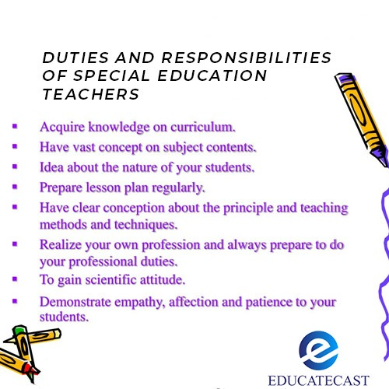

**Student Development and Growth**

1. Regularly evaluate student performance through formal and informal testing.
2. As outlined in the IEP, provide or oversee the personal, medical, and nutritional needs of the kids.
3. Take up the given responsibilities for extracurricular activities. Sponsor off-campus events that the campus administration has allowed.
4. Set an example for pupils and help the district's mission.
5. Establish a learning-friendly environment in the classroom that is also appropriate for the children' emotional, social, and physical growth.
6. Control student conduct and enforce rules. This involves stepping in during crises and restraining students physically as dictated by their IEP.
7. Discuss classroom management of student conduct in accordance with IEP with the instructors.
8. Speak with district staff members and other experts about the students' educational, social, medical, and personal needs.
9. Take all required and practical safety measures to safeguard students, tools, resources, and buildings.
10. As needed, offer assistance in choosing textbooks, tools, and other teaching resources.

**Communication**

1. By holding conferences with parents, students, administrators, and teachers, you can establish and sustain open communication.
2. Continue to interact professionally with coworkers, pupils, parents, and community members.
3. Present information in an accurate and understandable manner by using good communication skills. Job Description for Special Education Teachers Other
4. Attend staff development events to advance your job-related abilities.
5. Remain knowledgeable of and adhere to all district, state, federal, and school rules and special education teacher policies.
6. Gather, keep, and file all necessary reports, records, and other paperwork, both manually and digitally.
7. Participate in faculty meetings and, if needed, serve on staff committees.
8. Maintain discretion.
9. Other tasks as needed.
10. Supervise the designated teacher assistant, among other supervisory duties .